

Requirements – SSAP Paid Losses and LAE (After PMS Fiscal Close) Reversal

Prepared by: Shienny Juwita
March 3rd, 2025

Document Control

Change Record
Name | Role | Date | Version | Change Reference
Shienny Juwita | Preparer | 03/03/2025 | Draft
Lisa Nordling | Business Analyst | 05/02/2025 | Revision | Date clarifications
Shienny Juwta | Preparer | 05/05/2025 | Revision | Section 2 – Clarify on the journal effective date of entries. Added March 2025 entry and support. Added journal entry examples.

Reviewers
Name | Role | Date
Note to Holders:
If you receive an electronic copy of this document and print it out, please write your name on the equivalent of the cover page, for document control purposes.
If you receive a hard copy of this document, please write your name on the front cover, for document control purposes.
Purpose of this document
This document provides the business requirements for the SSAP Paid Losses and LAE (After PMS Close) reversal entry.

Contents
Document Control 2
Change Record 2
Reviewers 2
1. Introduction 5
1.1 Background 5
1.2 Document Scope 5
2. Key Business Decisions 5
3. Control Report 6
4. Data Extract for SSAP Paid Benefits After PMS Close 6
5. Journal Entry 8
6. Appendix 11
7. Open Items 11

Introduction

Background
During 2Q24 close, Actuarial identified that the incurred losses for Global Housing was materially higher than expected. The overage was due to the SSAP paid losses and LAE (~$21M) booked during the fiscal to calendar stub period. The GFS change from fiscal to calendar close for daily files processing (including moving the SSAP close date) allowed the SSAP activity for June 22nd – 30th, 2024 to flow through the AMU mapping process and post to the paid claims, claims LAE paid and claims ULAE paid accounts for June 2024 accounting month.

The SSAP paid loss and LAE payments processed during the fiscal to calendar stub period will be reflected in the PMS Loss Master in the next fiscal period and have been reserved for in the current fiscal period. Typically, the loss/LAE payments reduce the corresponding claim’s case reserves. Hence, a business decision was made to reverse SSAP losses and LAE payments during the stub period.

SSAP sub-ledger data is used to generate the SLIM accrual entry to reverse the Paid Claims, Paid LAE and Paid ULAE against a cash account. The reversal accrual entry impacts several legal entities and contains intercompany reinsurance activities for the Global Housing business.

Document Scope
This document focuses on documenting the business requirements for the entry to reverse SSAP losses and LAE payments that are related to products that are administered in PMS and made after the fiscal close until the end of the month. There are three products that are excluded from the process, which are listed in the next section.

Key Business Decisions
The following items are the key decisions made with respect to the reversal entries:
- Frequency: Quarterly. It could potentially be changed to monthly in the future.
- Timing:
    - 1st entry: the 1st day of the next calendar month. For instance, run on 4/1/2025 for March 2025 close. This is due to the material financial impact of the entry and the timing of P&L ledger lock. Entry is booked using the journal effective date on last day of reporting month (i.e. journal effective date 3/31/2025 for March 2025 close).
    - 2nd entry: the 2nd of the next calendar month to capture additional data for the current accounting month since the 1st entry, if any. For instance, run on 4/2/2025 for March 2025 close and book the additional data between 4/1/25 and 4/2/25, if any. Entry is booked using the journal effective date on last day of reporting month (i.e. journal effective date 3/31/2025 for March 2025 close).
    - 3rd entry: the 3rd of the next calendar month to capture additional data for the current accounting month since the 2nd entry, if any. For instance, run on 4/3/2025 for March 2025 close and book the additional data between 4/2/25 and 4/3/25, if any. Entry is booked using the journal effective date on last day of reporting month (i.e. journal effective date 3/31/2025 for March 2025 close).

Control Report
Create Power BI reports to capture the total functional amounts that will be used as control reports.
- Totals by Sub-Account and Journal Effective Date
- Totals by Sub-Account and Program
- Totals by Sub-Account and Entity

Dec 2024: SSAP Paid Benefits_After PMS Close_Summary_Dec 2024 1-5-25.xlsx
March 2025: SSAP Paid Benefits_After PMS Close_Summary_March 2025 4-2-25 AM.xlsx

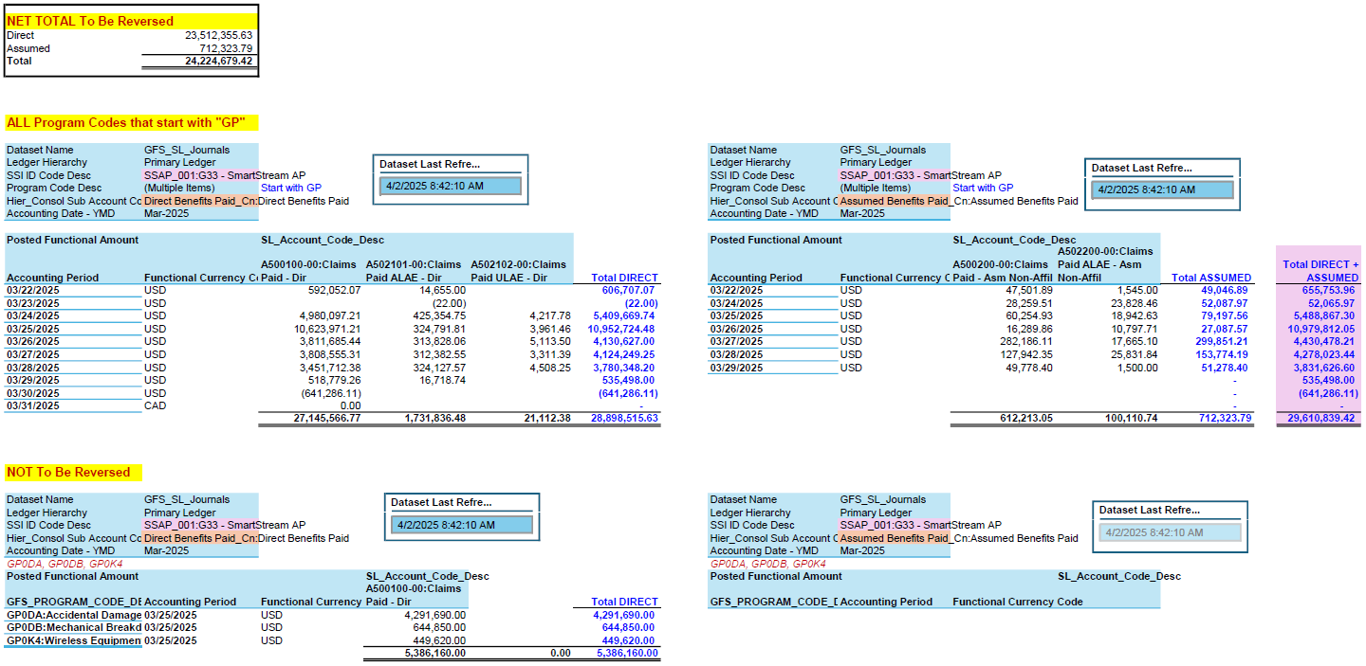

Data Extract for SSAP Paid Benefits After PMS Close
Parameters for data extract
- SSI Code “SSAP_001:G33 – SmartStream AP”
- Journal effective dates – dates between fiscal close date and end of the month date.
For instance, 3/22/25 – 3/31/25 since March 2025 fiscal close date is on 3/21/25.
2025 Closing Fiscal Calendar.pdf
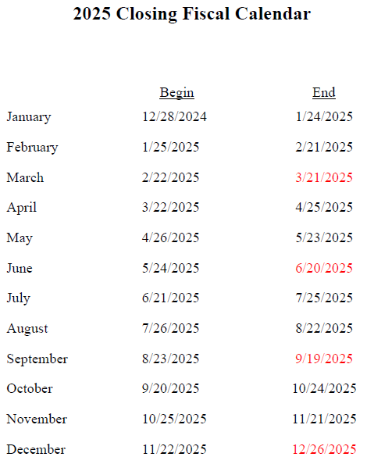

- Ledger Name “Primary Ledger”
- Program codes – start with “GP” except for GP0DA, GP0DB, GP0K4
- SL Accounts
    - Direct – P&L accounts that roll up to parent “Direct Benefits Paid” in the Sub-Account Consolidated hierarchy
    - Assumed – P&L accounts that roll up to parent “Assumed Benefits Paid” in the Sub-Account Consolidated hierarchy
    - Ceded – P&L accounts that roll up to parent “Ceded Benefits Paid” in the Sub-Account Consolidated hierarchy
- Total functional amounts should tie back to the PBI control reports mentioned in section 3 above at the Entity, Sub-account and Program level.

The data extract should include all the GFS fields listed in this file.
GFS Fields_Data Extract for SSAP Paid Benefits.xlsx

GFS Field | Value Example
Dataset Name | GFS_SL_Journals
Dataset Last Refreshed | 1/2/2025 20:09
Source_Interface_System_Code_Desc | SSAP_001:G33 - SmartStream AP
Amount_Class_Code | B000
Amount_Class_Desc | Cash
Ledger_Set_Code | Primary Ledger
Ledger_Name | USD Functional
Accounting Period | 12/28/2024 0:00
Journal_Date | 12/28/2024 0:00
Entity_Code | E00301
Entity_Desc | Assurant Captive Insurance Company
SL_Account_Code | A500100-00
SL_Account_Desc | Claims Paid - Dir
Center_Code | C810069
Center_Desc | Warranty ESC
Sub_Product_Code | P1383-000
Sub_Product_Desc | ESC - Extended Service Contract
GFS_PROGRAM_CODE | N/A
GFS_PROGRAM_DESC | Not Applicable
Bob_Code | WLWES
Bob_Desc | LOWES EXTENDED PROTECTION PLUS (EPP
Affiliate_Code | E00000
Affiliate_Desc | No Affiliate
GFS_REINSURER_CODE | N/A
GFS_REINSURER_DESC | Not Applicable
Risk_Location_Code | GA
Risk_Location_Code_Desc | GA:Georgia (US) - GA
Location_Code | L0001
Location_Desc | US Home Office
SL Journal Line Desc | 241228123 32470OPERA - *ATOMIC TECH LLC
Transaction Currency Code
Posted Transactional DR Amt | 0
Posted Transactional CR Amt
Posted Transactional Amount | 0
Functional Currency Code | USD
Posted Functional DR Amt | 340.25
Posted Functional CR Amt
Posted Functional Amount | 340.25
Reporting Currency Code | USD
Posted Reporting DR Amt | 340.25
Posted Reporting CR Amt
Posted Reporting Amount | 340.25

Journal Entry
  - Amount class: Accrual, reversing the following accounting month.

  - SL Journal Line Description:
Sub-Account | SL Journal Line Description
A115000-00 | Intercompany
A1T0110-00 | Cash on Deposit
Start with A5 | Paid Benefits

  - Sub-accounts:
    - P&L accounts – reverse all the transactions in the data extract.
    - Balance Sheet accounts
    - For transactions on VIIC (E00531), the balance sheet account is booked to an intercompany sub-account A115000-00 with ABIC (E01300), then on ABIC (E01300), we need to book the intercompany offset with VIIC and a cash sub-account A1T0110-00 (Cash on Deposit).
 | VIIC | ABIC | ABIC
Entity_Code | E00531 | E01300 | E01300
SL_Account_Code | A115000-00 | A115000-00 | A1T0110-00
Center_Code | C880400 | C880400 | C880600
Sub_Product_Code | P0000-000 | P0000-000 | P1450-000
GFS_PROGRAM_CODE | Blank | Blank | Blank
Bob_Code | MIHQOTL | MIHQOTL | M50000
Affiliate_Code | E01300 | E00531 | E00000
GFS_REINSURER_CODE | Blank | Blank | Blank
Risk_Location_Code | Blank | Blank | Blank
Location_Code | L0000 | L0000 | L0001
Functional Currency Code | USD | USD | USD

    - For transactions on RLIC (E01303), the balance sheet account is booked to an intercompany sub-account A115000-00 with ABIC (E01300), then on ABIC (E01300), we need to book the intercompany offset with RLIC and a cash sub-account A1T0110-00 (Cash on Deposit).
 | RLIC | ABIC | ABIC
Entity_Code | E01303 | E01300 | E01300
SL_Account_Code | A115000-00 | A115000-00 | A1T0110-00
Center_Code | C880400 | C880400 | C880600
Sub_Product_Code | P0000-000 | P0000-000 | P1450-000
GFS_PROGRAM_CODE | Blank | Blank | Blank
Bob_Code | MIHQOTL | MIHQOTL | M50000
Affiliate_Code | E01300 | E01303 | E00000
GFS_REINSURER_CODE | Blank | Blank | Blank
Risk_Location_Code | Blank | Blank | Blank
Location_Code | L0000 | L0000 | L0001
Functional Currency Code | USD | USD | USD

    - For transactions on ASIC (E00330), SGIC (E00331), ABIC (E01300) and CAPIC (E00721), the balance sheet accounts are to be booked to a cash sub-account A1T0110-00 (Cash on Deposit). There is no intercompany needed for these Entities.

 | ASIC | SGIC | ABIC | CAPIC
Entity_Code | E00330 | E00331 | E01300 | E00721
SL_Account_Code | A1T0110-00 | A1T0110-00 | A1T0110-00 | A1T0110-00
Center_Code | C880600 | C880600 | C880600 | C880600
Sub_Product_Code | P1450-000 | P1450-000 | P1450-000 | P1450-000
GFS_PROGRAM_CODE | Blank | Blank | Blank | Blank
Bob_Code | M50000 | M50000 | M50000 | M50000
Affiliate_Code | E00000 | E00000 | E00000 | E00000
GFS_REINSURER_CODE | Blank | Blank | Blank | Blank
Risk_Location_Code | Blank | Blank | Blank | Blank
Location_Code | L0001 | L0001 | L0001 | L0001
Functional Currency Code | USD | USD | USD | USD

The entry has to be recorded at the following granularity to the sub-ledger.
GFS Field
1 | Entity_Code
2 | Amount_Class_Code
3 | SL_Account_Code
4 | Center_Code
5 | Sub_Product_Code
6 | Location_Code
7 | Affiliate_Code
8 | Bob_Code
9 | GFS_REINSURER_CODE
10 | GFS_PROGRAM_CODE
11 | Risk_Location_Code
12 | Functional Currency Code
13 | Posted Functional Amount

Journal Entry Examples
SSAP Paid Benefits Rvsl_JE Examples.xlsx
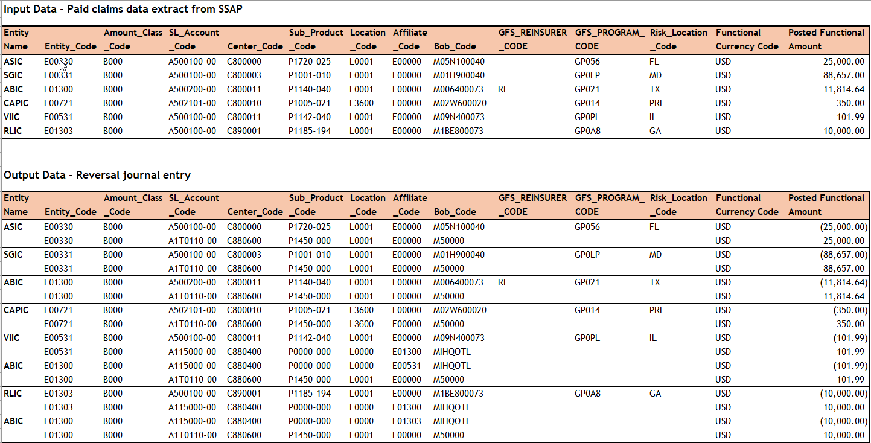

Appendix
December 2024 journal entry and support for reference.
SAMU SLIM - SSAP Pd Benefits After PMS Close Reversal_Dec 2024.xlsm
SSAP Paid Benefits After PMS Close_JE Support_Dec 2024 1-2-25.xlsx

March 2025 journal entry and support for reference
SAMU SLIM - SSAP Pd Benefits After PMS Close Reversal_March 2025 4-1-25.xlsm
SSAP Paid Benefits After PMS Close_JE Support_March 2025 4-1-25.xlsx

Open Items
ID | Item | Open Date | Closed Date | Owner | Comment/Next Step

